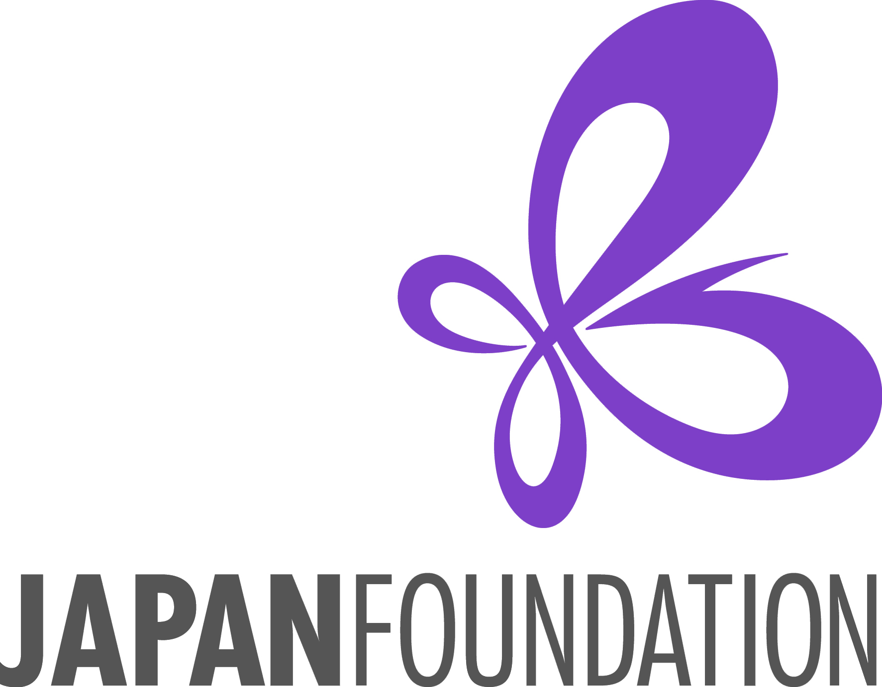

Fiscal Year 2025-26

## Japanese Language Learners Event Grant

**Application Instructions**

**Program Description**

The Japan Foundation, Los Angeles (hereafter “JFLA”) provides financial assistance for events such as speech contests, quiz contests, and presentational events which motivate large numbers of Japanese-language learners from **multiple schools**, feature different educational levels (primary, secondary, collegiate level, and adults), and promote Japanese-language education on the **national/state/regional level.**   
\***Closed events for a single school are not eligible.**

**Grant amount:** Up to **$1,000**

*Grantees will now be required to submit proof of payment which show that payment has actually been completed and received by vendor for all expenditures.

**Eligible Events for Support**

Events must start and conclude **between April 1, 2025 and March 31, 2026**.

Proposed events cannot be implemented for commercial, political, or religious purposes.

1. The following expenses are **eligible** for support:

* **Expenses for inviting judges/guests to the event** (honoraria, transportation, accommodation),
* **Expenses for venue** (rental fee for venue and equipment, service fee for tech support, etc.),
* **Prize expenses for participating Japanese-language learners** (no cash prizes),
* **Production costs for handouts/programs/flyers of the event**.
* **Group transportation costs for participants/student audiences** (charter buses, vans, etc.)

1. The following expenses are **NOT** **eligible** for support:

* Banquet costs and entertainment costs
* Expenses for any food or drinks
* Indirect costs (administrative costs) not related to the grant project
* Rental fees for halls owned by the applying institution/organization or group
* Any administrative costs of the managing division (staff salary, office supplies, etc.)
* Expenses related to holding general meetings which are regularly held by the applicant regardless of the event

**Eligible Applicants**

1. Applicants must be non-profit institutions/organizations involved in Japanese language education in the U.S. (Individuals are not eligible to apply.)
2. In principle, the Japan Foundation does not provide grants for:
   1. The U.S. government, including their administrative organs such as ministries and their embassies and consulates-general in Japan; excluding academic, cultural, or research institutes such as universities and museums
   2. Institutions/organizations to which the Japanese government currently makes financial contributions
   3. Institutions/organizations whose laws restrict them from receiving aid from foreign organizations affiliated with governments
   4. Institutions/organizations which serve commercial, political, or religious purposes
3. Applicants must have a bank account in the institution’s name capable of accepting grants from the Japan Foundation. A bank account may also be opened before the grant payment. Receipt of grants or benefits from the Japan Foundation must not violate any laws or ordinances, etc.
4. If your application is successfully selected for our grant support, the grant will be paid by check. Failing to submit your signed Acceptance of Grant & Request for Payment form by the specified due date (within 2 months of notice of grant approval) could result in JFLA rescinding its grant.

**Screening Criteria**

Applications will be reviewed based on the following criteria:

1. Projected benefits of the project to the Japanese-language learners in the region
2. Projected results/effects of the project on Japanese-language education in the region
3. Scale of project and the number of contestants and participating schools
4. Role of applying institution(s)/organization(s) in the region
5. Necessity of financial support from JFLA (financial status, potential to raise funds from sources other than JFLA, etc.)
6. Previous grant history

**Application Procedures and Deadlines**

**Application Deadlines: 1st Deadline: March 1, 2025**

**2nd Deadline: September 1, 2026**

(When the deadline falls on a weekend, it will be extended to the following Monday.)

**Mailing Address:** The Japan Foundation, Los Angeles

Attn: Jared McClellan

5700 Wilshire Blvd. #100  
Los Angeles, CA 90036

1. Please be sure to inform the JFLA (jared_mcclellan@jpf.go.jp) of your intent to apply for the grant prior to submitting your application.
2. A complete application form **with either a handwritten signature OR a verified e-signature** must be submitted, by postal mail or email (scan), to the JFLA office on or before the deadline – **no late applications will be accepted at this time**.

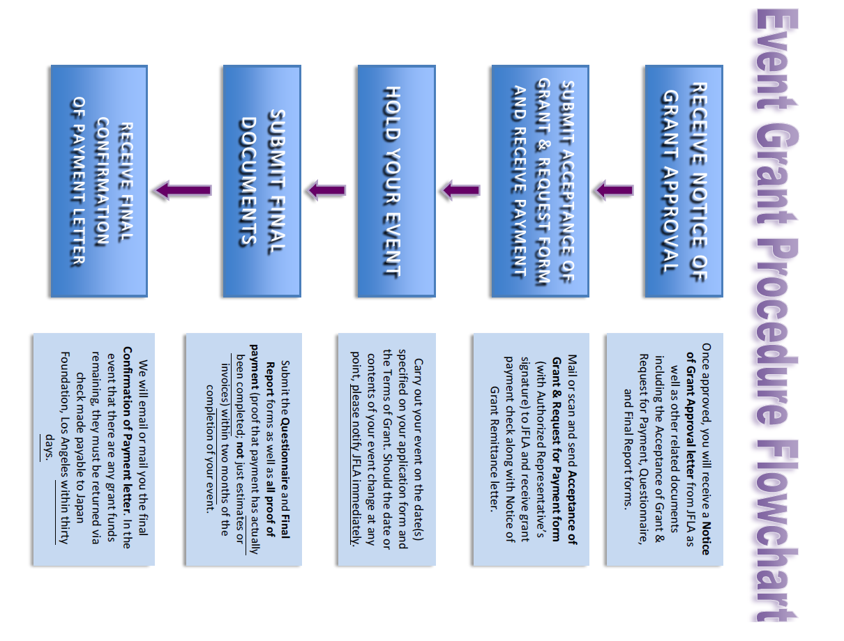

**Obligations of Grantees**

1. Programs of the Japan Foundation are operated in accordance with its own regulations as well as the relevant laws and regulations including “Law for the Proper Execution of a Budget Relating to Subsidies” (Law No. 179 of 1955)
2. Please acknowledge the JFLA grant support in any distributed publications and/or promotional materials.
3. Applicants must submit the following required documents: (1) **“Final Report”** with handwritten signature, and (2) the **“Questionnaire” form**, and (3) all **proof of payment** (receipts/invoices which show that payment has actually been completed).

**Disclosure of Information**

1. Details of projects supported by the Japan Foundation (e.g., the name of the applicant and project descriptions only; the grant amount will not be made public) will be made public in the *Kokusai* *Kōryū Kikin Jigyō Jisseki* (Detailed Annual Report of the Japan Foundation), on the Japan Foundation's website, and in other public-relations materials.
2. When a request for information based on the "Law Concerning the Disclosure of Information Held by an Independent Administrative Institution, Etc." (Law No. 140 of 2001), is received, materials such as submitted application forms will be disclosed (unless stipulated by laws as not to be disclosed).

**Handling of Personal Information**

1. The Japan Foundation handles personal information appropriately and in accordance with the "Law Concerning Access to Personal Information Held by Independent Administrative Institutions" (Law No. 59 of 2003). Details of the Japan Foundation's personal information protection policy can be reviewed at: <http://www.jpf.go.jp/e/privacy>
2. The Japan Foundation uses personal information on the application materials for screening, implementation, and evaluation procedures of the project. It may also be used for the following purposes:
3. Details of the successful applicants, such as names, gender, job and position, affiliation, project duration, and project description, are published in the *Kokusai Kōryū Kikin Jigyō Jisseki* (Detailed Annual Report of the Japan Foundation), the Annual Report, on the Japan Foundation's website, in other public-relations materials. They are also used in compiling statistics and released to the press for publicity purposes.
4. There may be cases in which these details are released to Ministry of Foreign Affairs of Japan, or the Embassies or Consulates-General of Japan at the place where a project is undertaken.
5. There may also be cases in which copies of applications, including documents containing some personal information, are provided to outside consultants in order to facilitate the screening process and the evaluation of the results of projects. The Japan Foundation requests the consultants to take measures to ensure the safety of the provided personal information.
6. There may also be cases in which the Japan Foundation sends questionnaires to the addresses written on this form after the project has ended.
7. There may also be cases in which the Japan Foundation uses the information written on the application form to contact the applicants to inform them of other Japan Foundation activities.
8. Applicants are requested to inform all individuals whose personal information appears on the application materials of the above-mentioned policy.

There may be cases in which the project reports and other related publications are released to the public.

Contact

Please feel free to contact The Japan Foundation, Los Angeles if you have any questions.

**The Japan Foundation, Los Angeles**

Jared McClellan, Japanese Language Program Coordinator

5700 Wilshire Blvd. #100, Los Angeles, CA 90036

Tel: 1-323-761-7510, ext. 112

Email: [jared_mcclellan@jpf.go.jp](mailto:jared_mcclellan@jpf.go.jp) URL: www.jflalc.org